LOADING THE DATASET

You must connect your data to IBM Cognos before you can create a view and perform any analysis. Cognos allows users to connect to a large range of data that is kept in many locations.

The information may be kept on your computer in a spreadsheet or text file, or it may be kept on a server at your company in a big data, relational, or cube (multidimensional) database.

In this instance, we'll do our analysis utilising a spreadsheet or text file.

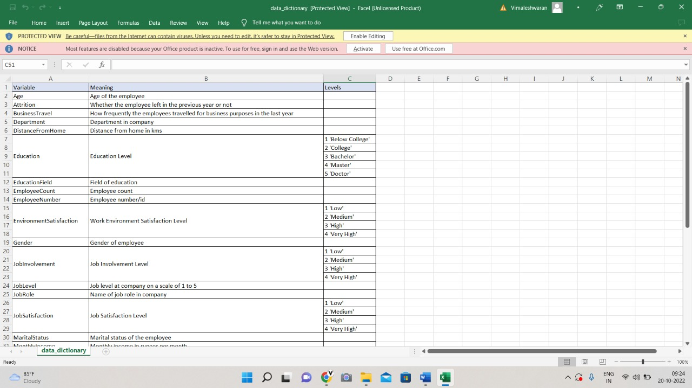

Upload data

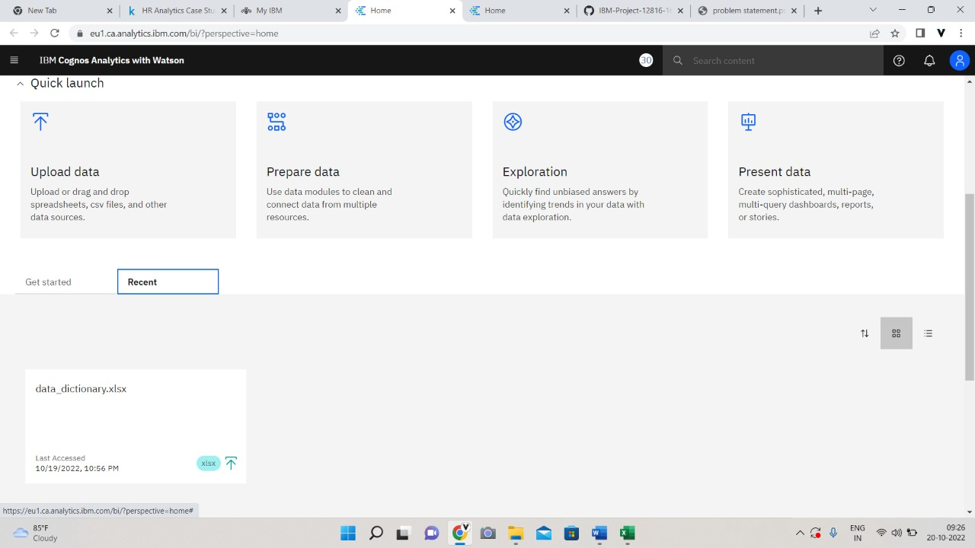

Prepare dataset

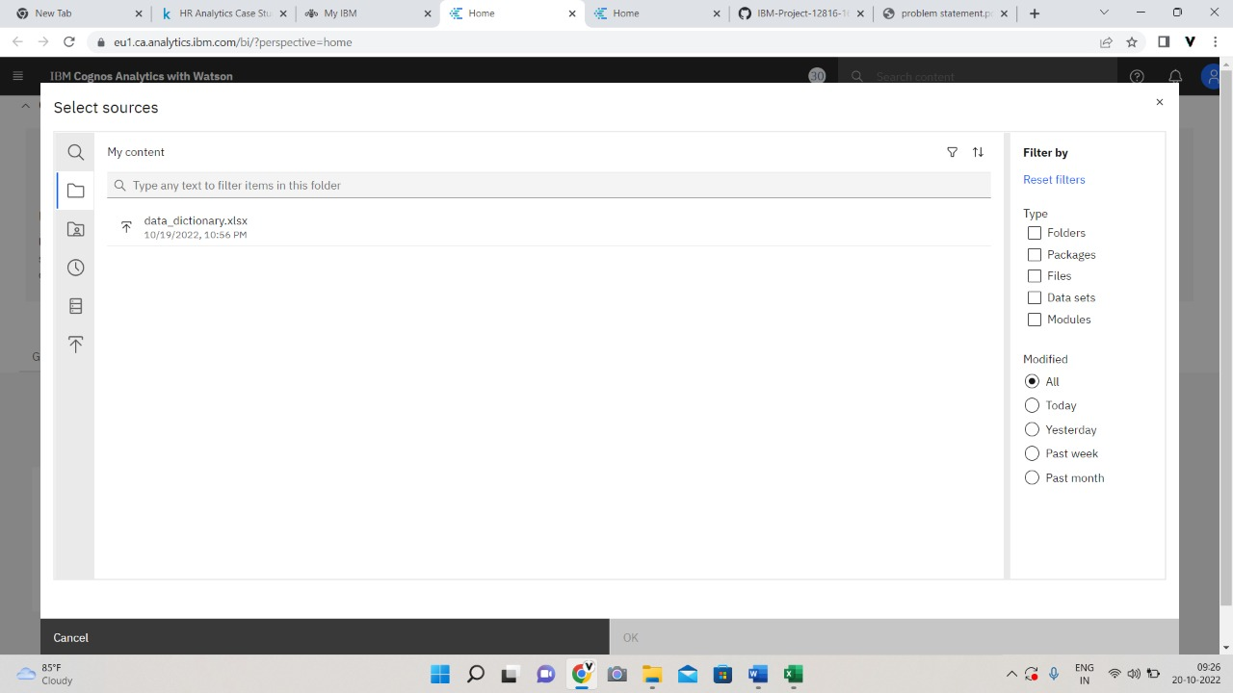

Select the dataset

